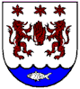
O’Neill/Kenney Family History
